Ideation Phase
Empathize & Discover

Date | 25 June 2026
Team ID
Project Name | An employee requests installation of licensed software through the Service Catalog
Maximum Marks | 4 Marks

Empathy Map Canvas:
The Empathy Map Canvas was used to understand the needs, challenges, and expectations of employees requesting licensed software through the ServiceNow Service Catalog. It helped the team analyze the user's thoughts, actions, concerns, and experiences during the software request process. By identifying pain points such as manual approvals, delayed installations, and limited request visibility, the team designed an automated workflow with approvals, catalog tasks, and status tracking. This user-centered approach ensured the solution improved efficiency, transparency, and overall user satisfaction while simplifying the software installation request process.
Example:
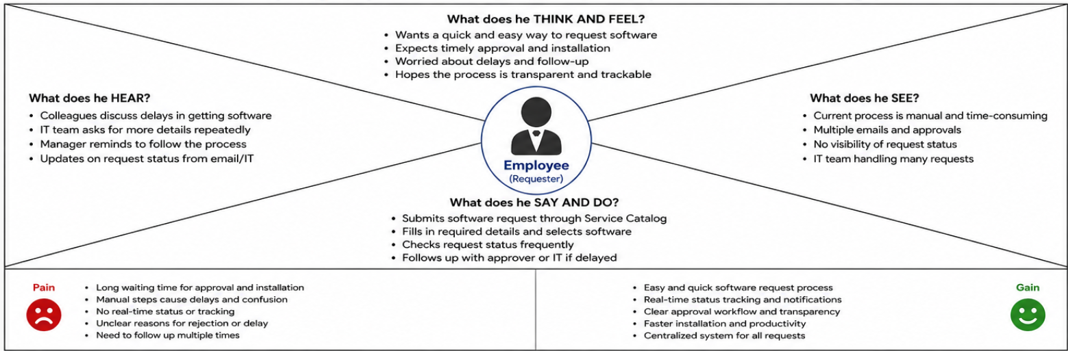

Reference: https://www.mural.co/templates/empathy-map-canvas

Example: Food Ordering & Delivery Application
